BUG REPORT

CATEGORY | LABEL | VALUE
Bug ID | Bug ID | 001
 | Reporter Name | Isaac Banda
 | Submit Date | 07/04/2026
Bug Overview | Summary | Unauthenticated access not blocked
 | URL
 | Screenshot | Attached Below
Environment | Platform | PC
 | Operating System | Windows 11 Pro
 | Browser | Chrome
Bug Details | Steps to produce | Change the role at the end of the ULR (staff,tutor,student)
 | Expected result | Redirected to login page
 | Actual result | Opens dashboard page of typed role
Bug Tracking | Severity | very
 | Priority | High

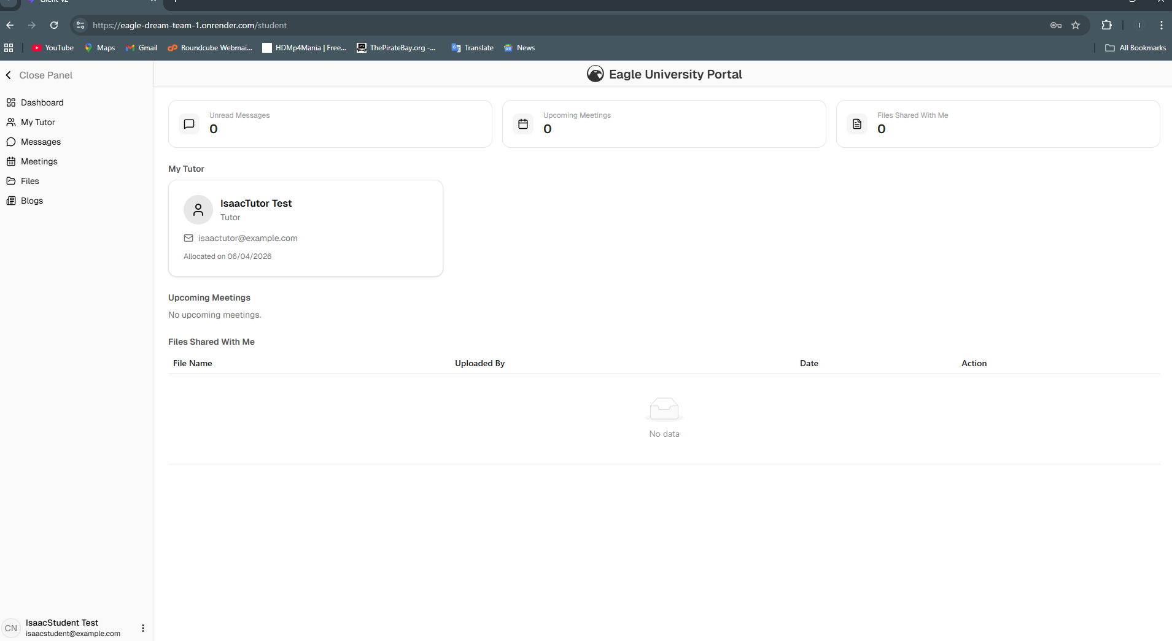
Logged in as Student

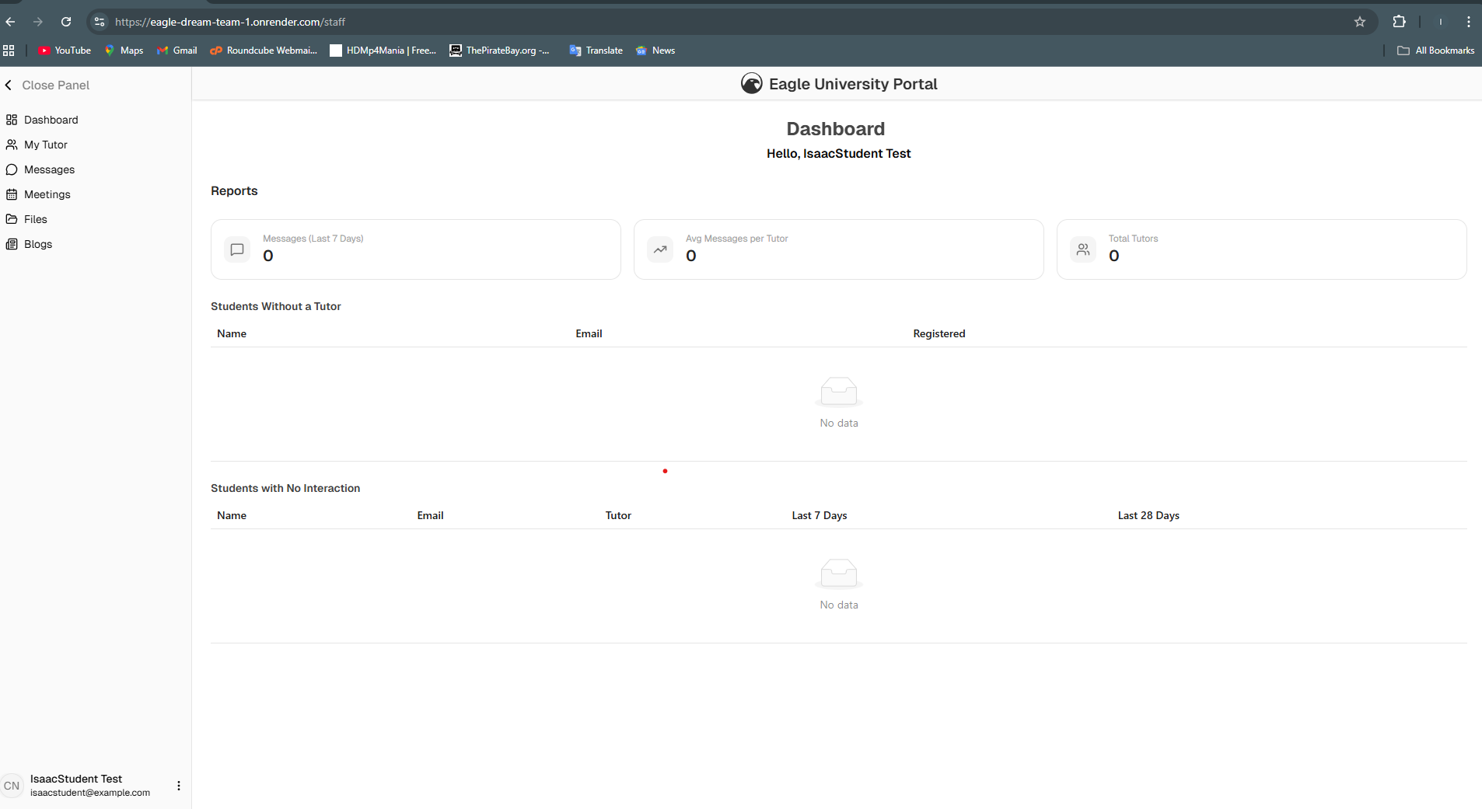
When student is replaced with staff at the end of the URL

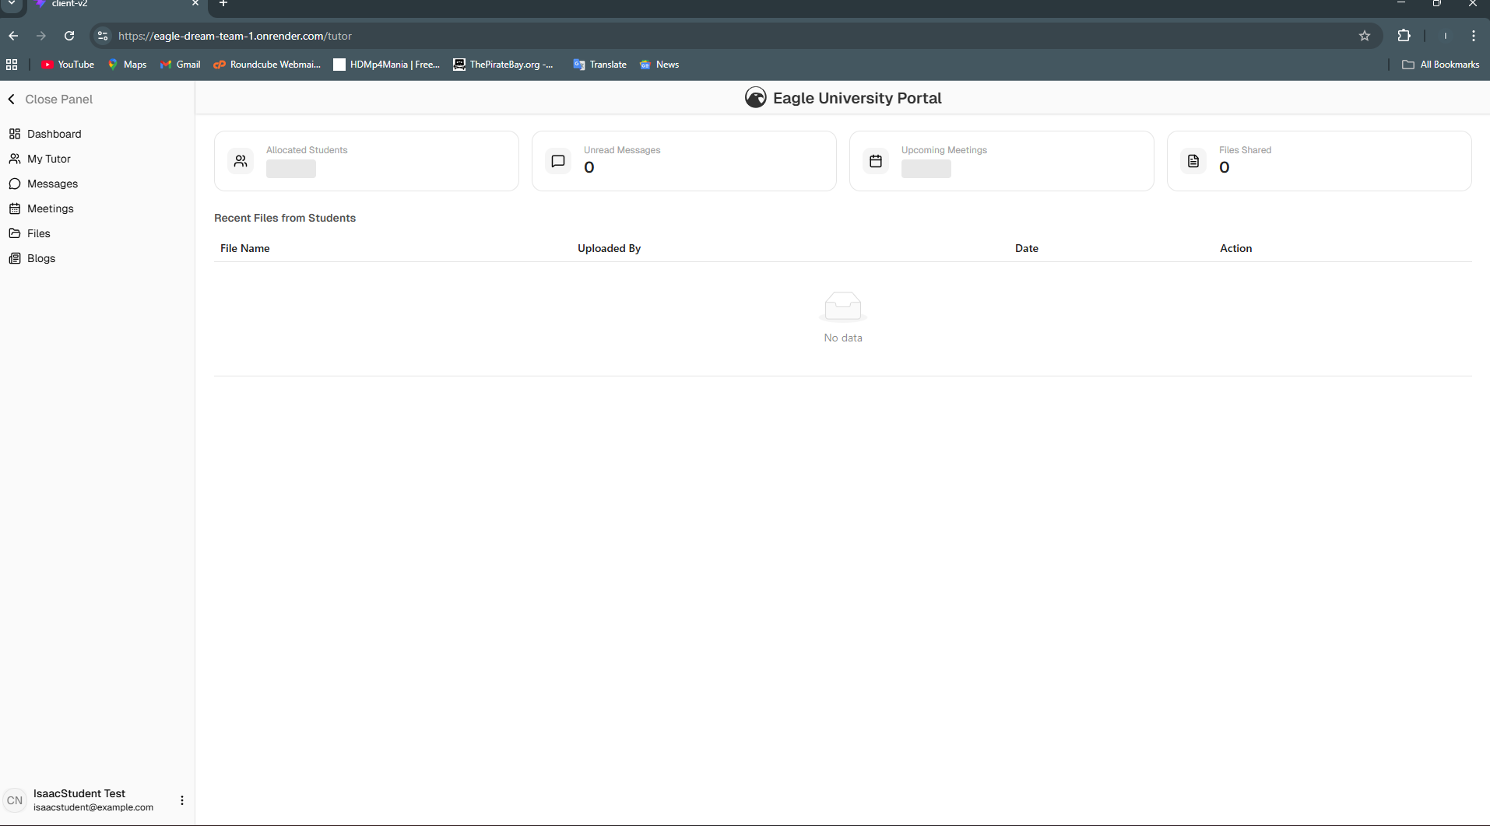
When student or staff is replaced with tutor at the end of the URL

